Github link - https://github.com/jocooper317/SDEV153-WebPage.git
Chapter 2 Yurts
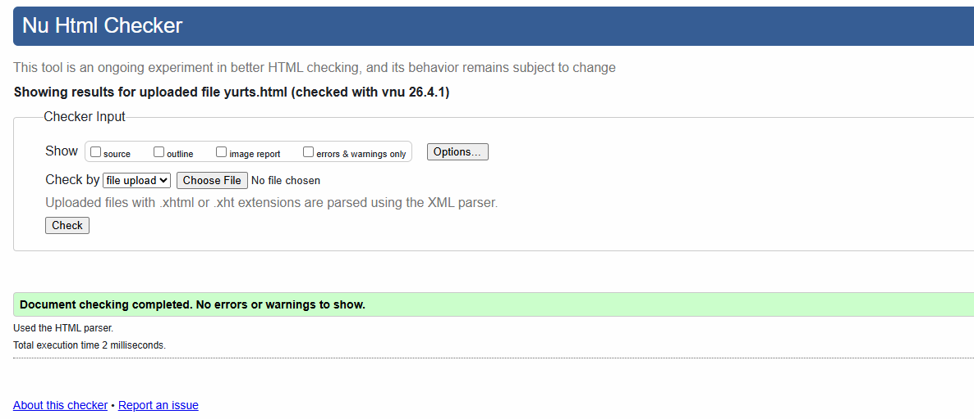
Chapter 2 Index
